Input: The input is in the form of a transition table of the dfa as shown

Ex:

q0 q1 q5
q1 q6 q0
q2f q0 q2f
q3 q2f q6
q4 q7 q5
q5 q2f q6
q6 q6 q4
q7 q6 q4

1st Column denotes the state of pda.
2nd Column denotes the output state on input symbol 0 for the state
3rd Column denotes the output state on input symbol 1 for the state

i.e qo-⁰ >q1 , qo-¹ >q5

Output: In the output Ihave printed the set of states which are equivalent to each other as followed in the dfa minimizaion process.

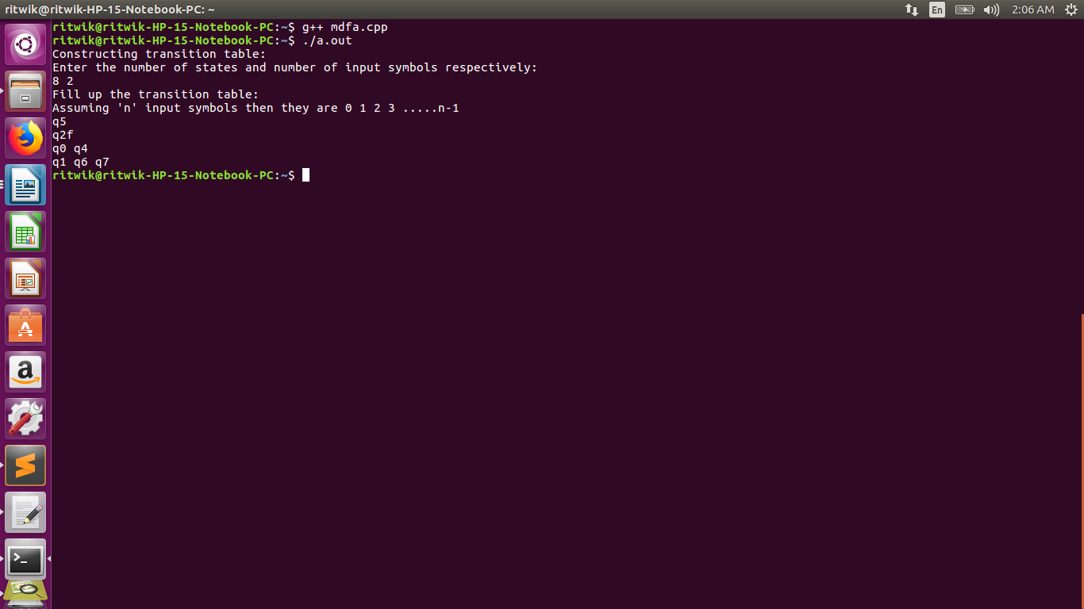
In the output I have mentioned the set of elements that are equivalent.

Code:

At first I have removed the unreachable states.

Ex: Here q3 in unreachable state.

Initially I have given all initial states id 0 and final states id 1
I have used a while loop that runs for max s-1 times where ‘s’ denotes number of states .

In each iteration I have for the input symbol in column 0 the output for states belong to same set or not. Elements in the same set have the same id.

Ex :

q1-⁰ >q6
q7-⁰ >q6
q5-⁰ >q2f

Hence ‘q1’ and ‘q6’ belong to the same set hence their id won’t change. However ‘q5’ belong to different set hence it will get new id which is (id of q2f +1) . This process will occur for each iterartion. Finally at the end we have the various id’s for the states where states with same id’s belong do same set which can be combined thus minimizing our dfa.
I stored them in a map where key is the id and value is the states having the corresponding id.

